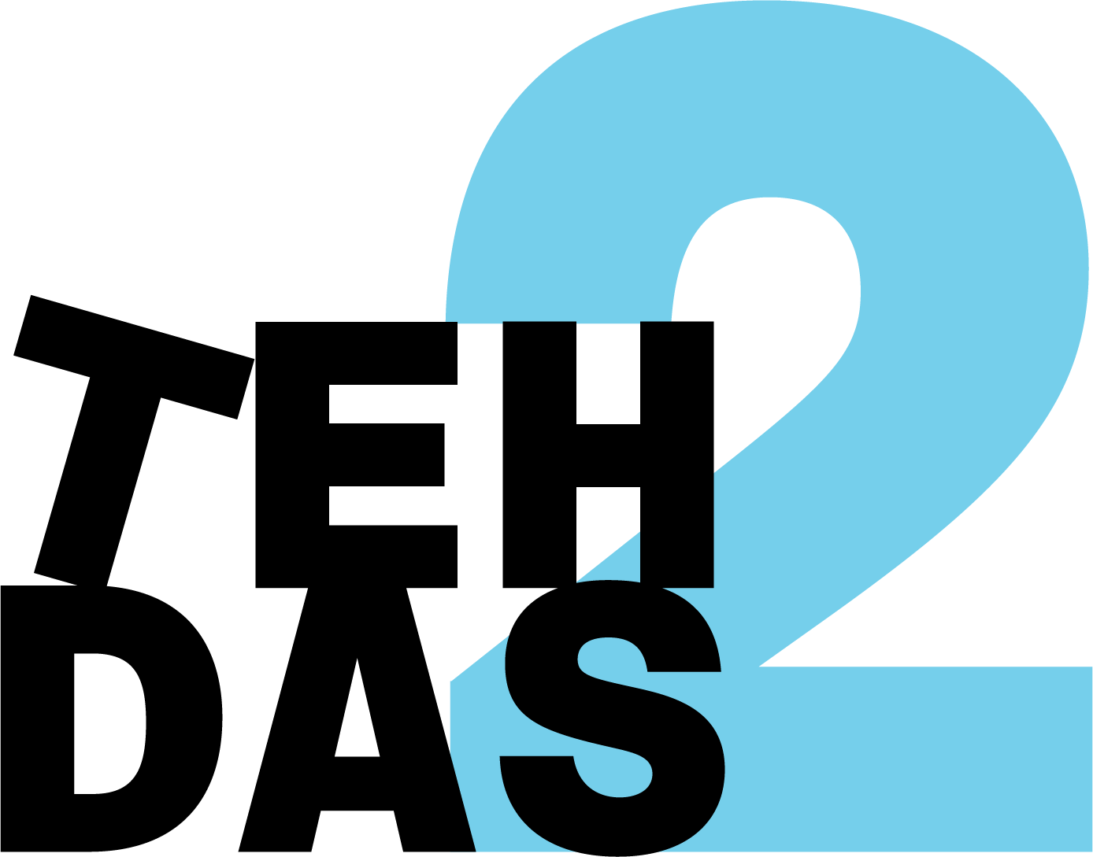

TEHDAS2 public consultation on Draft guideline for Health Data Access Bodies on international and third country access and transfer of electronic health data

Mandatory questions are marked with a star (*)
This consultation has 6 pages and 30 questions. The first and the second pages are common to all TEHDAS2 public consultations and cover demography of the responder and overall quality of the document. Pages 3, 4, 5 and 6 consist of questions specific to this document.

Demography

1. Country *

Netherlands

2. Type of responder *
Other: research infrastructure

3. Are you responding behalf of several organizations? *
If yes: On behalf of how many organisations?
No

4. Sector *
Other: research infrastructure

5. Organisation size *
Small to medium enterprise (10–249 employees)

6. Professional role / function

Program manager

7. Is the document easy to understand? *
Not clear nor easy to understand
3
1
4
Very clear and easy to understand
I don't know

8. How well does the document address the key issues related to its subject matter? *
Not well
3
1
4
Rate
Very well
I don’t know

9. How feasible do you find the guidelines or technical specifications to implement, as outlined in the document? *
Not feasible and implementable at all
3
1
4
Rate
Very feasible and implementable
I don’t know

10. Generic feedback
Do you have any suggestions for improving the document? Are there any additional topics or areas that should be covered? Max. 5000 characters.
5000 characters left

For readability, chapters 2 and 3 could be an attachment.
We observe that the guidelines have largely been developed and described as separate documents by different authors (which is understandable), but therefore there is limited visibility of how they relate to one another within the broader process.
Greater horizontal alignment across the guidelines is needed to support a clear and coherent data journey. This would help stakeholders understand how the different components fit together, ensure consistency across the framework, and facilitate practical implementation throughout the entire data lifecycle.
The implementability of the guidelines is a concern. Implementation should start with a minimum viable end-to-end data journey and evolve through an iterative learning and growing process. Rather than regulating all details from the outset, requirements should be introduced in phases, allowing experience and evaluation to inform further development and requirements.
At the same time, sufficient harmonisation is needed to prevent divergent national interpretations and implementation approaches. Therefore, each phase should include clear, directly applicable requirements that ensure consistent implementation across Member States growing into a more robust and mature legislation.

The following questions are specific for TEHDAS2 Draft guideline for Health Data Access Bodies on international and third country access and transfer of electronic health data

Role and experience

11. Are you involved in international access to, or transfer of, electronic health data (e.g. as HDAB, data holder, data user, supervisory authority, secure processing environment provider)? *
Yes. Further, I expect to take part in HDAB roles/responsibilities in the future.

12. What are you representing? *
Research infrastructure

13. How experienced are you with cross-border or international data access and transfer arrangements (including with third countries or international organisations)? *
1 (no experience; not at all) – 4 (extensive experience; on a regular basis)
No experience
3
1
4
Rate
Extensive experience

14. In your current role, have you already been involved in:
Assessing international data access requests
Drafting/negotiating data transfer agreements
Operating or using a secure processing environment for cross-border access
Supervising or auditing international transfers
Other (please specify)

No

If yes, could you provide examples?
Max. 5000 characters.
5000 characters left

15. Do you already rely on specific national rules, internal policies or templates for international access or transfers (beyond the GDPR)?
No

If yes, please briefly describe:
Max. 5000 characters.
5000 characters left

Clarity of access pathways (authorised participation and reciprocity)

16. How clear is the description of the two main access scenarios/pathways (authorised third-country participation in HealthDataEU or reciprocity-based access under Article 91(1)(b))? *
Please rate from 1 (not clear) to 4 (very clear).
Not clear
3
1
4
Rate
Very clear
Not applicable

17. Do you consider that the guideline sufficiently explains the criteria and process for recognising an authorised participant (Article 75(5) in conjunction with Article 91(1)(a))?*
Please rate from 1 (incomplete) to 4 (exhaustive).
Incomplete
3
1
4
Rate
Exhaustive
Not applicable

Please explain your rating:
Max. 5000 characters.
5000 characters left

18. Is the distinction between access based on authorised participation and access based solely on reciprocity (including the different timelines of application) sufficiently clear for practical implementation? *
Rate from 1 (incomplete) to 4 (exhaustive).
Incomplete
3
1
4
Rate
Exhaustive
Not applicable

Please explain your rating:
It is quite clear, although more information could be given on the practical consequences of both options.
5000 characters left

Governance, roles and procedures for HDABs

19. To what extent is it clear which tasks and responsibilities fall on the actors (e.g. European Commission, Health Data Access Bodies, National Contact Points) involved in international health data access and transfer scenarios within the EHDS framework? *
Rate from (not clear at all) to 4 (very clear)
Not clear at all
3
1
4
Rate
Very clear
Not applicable

20. What challenges do you foresee in implementing the recommended governance arrangements in your national and/or organisational context (e.g. coordination between authorities, resource needs, expertise)?
The guideline suggests thorough and careful evaluation of data access applications in international settings. This requires sufficient resources. Also, harmonized review processes between member states are essential.
5000 characters left

21. Are there in your national and/or organisational context, aspects of governance or institutional cooperation that you consider missing or under-developed (e.g. interaction with data protection authorities, international coordination, role of research infrastructures)?
Max. 5000 characters.
Yes, what seems to be missing is the role of the EHDS Board. We advise thatthe EHDS Board has a role in determining, for example an advisory role, whether a third country can join based on reciprocity or whether an organization can be given the status as authorised participant.

Legal framework and interaction with other EU instruments

22. Do you consider that the guideline sufficiently addresses the relationship between EHDS rules on international access/transfers and other instruments (e.g. adequacy decisions, standard contractual clauses)? *
Rate from 1 (incomplete) to 4 (exhaustive)
Incomplete
1
1
4
Rate
Exhaustive
Not applicable

Please explain your rating:
This could be addressed in more detail. For example, if a third country is deemed eligible, but does not have an adequacy decision and SCCs are not possible, will there be standard contracts? What can and should dataholders and users make decisions on? If much room is left to set up an own contract, this will definitely hinder the speed at which data access can be granted and might even lead to misuse of the process.
5000 characters left

23. Are there specific legal or interpretative questions that you feel require further clarification in the guideline?
Max. 5000 characters.
Yes, if a third country is eligible, but has not been given an adequacy decisions, contracts are needed between the data holder and user. Especially if there are no (obligatory) standard contracts, what will be the consequence of the process of reaching agreement on the contract on the timing of data access?

24. What legal or regulatory conflicts or overlaps do you foresee when applying the guideline in your jurisdiction (if any)?
See 23
5000 characters left

Practical usability and implementation challenges

25. Overall, how practically useful is the guideline for supporting real-world decisions on international access to, and transfer of, electronic health data? *
Rate from 1 (not useful at all) to 4 (very useful)
Not useful at all
3
1
4
Rate
Very useful
Not applicable

26. Which parts of the guideline do you find most helpful (e.g. description of scenarios, recommendations section)?
Max. 5000 characters.
5000 characters left

27. Which chapters do you find most difficult to understand?
Chapter 3 – Survey
Chapter 4 – Scope of the guideline
Chapter 5 – Access application
Chapter 6 – EHDS provisions
Chapter 7 – Interdependencies with other TEHDAS2 deliverables
Chapter 8 - Recommendations

28. What main implementation challenges do you anticipate in applying the guideline in your organisation or country (e.g. resources, expertise, alignment with national law, cross-border coordination)?
Resources for the HDAB and cross-border coordination (e.g. ethical review).
5000 characters left

29. Would additional tools or support (e.g. checklists, templates, model clauses, training, case studies) help you in applying the guideline? If yes, please specify which ones.
Yes, checklists, standard contracts and case studies.
5000 characters left

30. Any other comments or suggestions regarding the scope, structure or content of the guideline on international and third-country access and transfer of electronic health data?
Max. 5000 characters.
5000 characters left

The guideline should also point at the importance of providing early guidance regarding third country access. Importantly, access by third countries should never be used as means of pressure or strategic instrument.

