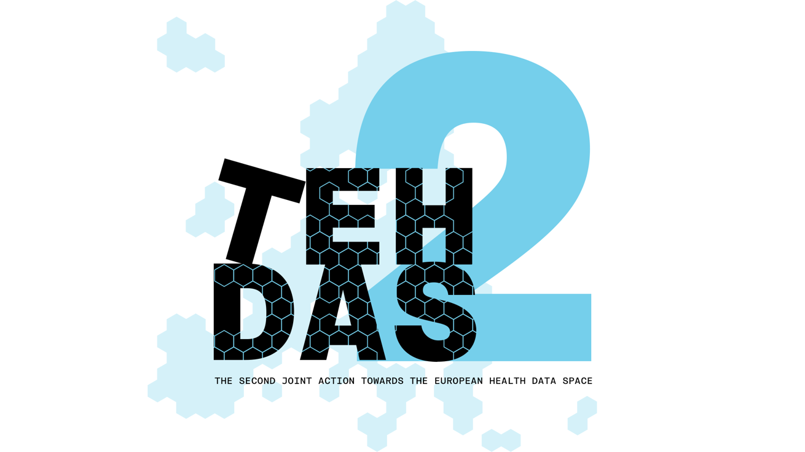

​M4.2 Draft guideline on a framework for collaboration – public consultation questions
TEHDAS2 – Second Joint Action Towards the European Health Data Space

21 April 2026

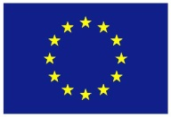
Co-funded by
the European Union
0 Document info

Disclaimer
Views and opinions expressed in this deliverable represent those of the author(s) only and do not necessarily reflect those of the European Union or HaDEA. Neither the European Union nor the granting authority can be held responsible for them.

Copyright Notice
Copyright © 2024 TEHDAS2 Consortium Partners. All rights reserved. For more information on the project, please see.

Introduction
By committing to a rigorous public consultation process, the TEHDAS2 project ensures that its deliverables are not only compliant with regulatory requirements but also practical, feasible, and supported by the community they are intended to serve.

Part A questions for generic feedback
These questions will be asked in each public consultation to provide an understanding of the recipients’ demographics, the quality of the document and to gather generic feedback. Questions marked with an asterisk are mandatory.

Demography
Country
Netherlands
Type of the responder
other, research infrastructure
Are you responding on behalf of several organisations?
No
Sector
other, research infrastructure
Organisation size
Small to medium enterprise (10–249 employees)
Professional role/function
program manager

Quality
Is the document easy to understand? [Rate 1 (Not feasible at all) – 4 (Very feasible)]
3. The guideline includes all necessary information and the structure is good. To make the guideline more comprehensible it would be better to include some sections in the annex, for example the description of the stakeholder meetings.
How well does the document address the key issues and challenges related to its subject matter?* [Rate 1 (Not well) – 4 (Very well)]
3. The guideline is not entirely complete, but quite comprehensive. It is positive that the document addresses the fragmentated landscape.
How feasible do you find the guidelines or technical specifications presented in the document?* [Rate 1 (Not feasible at all) – 4 (Very feasible)]
2. While the recommendations are sound there are quite generic, operationalization is required. Considering the scope of the content, a three-year timeframe may be ambitious.

Generic feedback
Do you have any suggestions for improving the document? Are there any additional topics or areas that should be covered? [Please provide feedback and ideas for enhancing the document] [max. 5000 characters]
The guideline provides a comprehensive overview of the challenges that diverse forms of collaboration under the EHDS may encounter, reflecting a range of perspectives. It also sets out an extensive set of recommendations aimed at mitigating these challenges.
We observe that the connections and alignment between the different guidelines are not sufficiently clear. Greater consistency and cross-referencing between the guidelines would improve coherence, reduce the risk of conflicting interpretations, and facilitate more effective implementation.
We observe that the guidelines have largely been developed and described as separate documents by different authors (which is understandable), but therefore there is limited visibility of how they relate to one another within the broader process.
Greater horizontal alignment across the guidelines is needed to support a clear and coherent data journey. This would help stakeholders understand how the different components fit together, ensure consistency across the framework, and facilitate practical implementation throughout the entire data lifecycle.
Another concern we would like to address is that the TEHDAS guidelines timelines do not always match the comitology implementing acts timelines, which make it hard to assess the effect of the input on both trajectories and how input on the guidelines will have effect on the implementing acts. Timeline alignment is needed.

Part B questions for specific feedback

Part I – Conditions for Collaboration
Topic 1: Ethical governance
- Are there any significant challenges related to ethical governance under the EHDS that are not reflected in this section?

- Most challenges are included in the document. But we do miss the challenge of different visions between countries on ethical governance. For example, countries differ a lot in their vision on working together with commercial organizations and weighing commercial interests. But visions may also differ on other topics as well (coming from different cultural backgrounds).

- Do the recommendations on ethical governance adequately address the challenges identified? Are there recommendations you would add or prioritize differently?

- It would be good to have a set of practical recommendations like a balancing framework or a blueprint for an ethical commission to stimulate alignment between countries.

- Given that, historically, various ethical review structures already exist at the local and regional levels (e.g. universities and international collaborations each having their own ethics committees), how does the guideline propose aligning these structures at both the national and international levels?
- How does the working group envisage the interaction between these existing ethics committees and the national HDAB, as well as between different HDABs, particularly with regard to avoiding duplication of assessments?
- The guideline mentions ‘the continued role of ethics committees’ as ‘an important condition for the effective and ethical implementation of the European Health Data Space’. If ethical review is no absolute requirement of the data access/request evaluation (since it is left up to the member states to choose whether to implement this review at a national level), what role is envisioned for these ethics committees? A clearer guideline on what ethical frameworks are mandatory under the EHDS and what ethical frameworks are left up to member states to define, would be beneficial. Recommendation 3 dictates that member states should clarify these interactions as part of their national implementation arrangements, but in order to do so, it must be clear what responsibilities and obligations lie with which party.

Topic 2: Collaboration models and coordination mechanisms
- Are there any significant challenges related to collaboration and coordination under the EHDS that are not reflected in this section?

- From a data holder perspective (p. 9), the document emphasizes the risk of excessive bureaucracy, primarily from the viewpoint of data requesters. However, the impact on data holders should also be duly considered. Variations in approval procedures and institutional requirements across countries are likely to create substantial additional administrative burden.

- Do the recommendations on collaboration models adequately address the challenges identified? Are there recommendations you would add or prioritise differently?

- The recommendations emphasizing the need to align systems and ensure interoperability will also help address this issue. It would be beneficial to consider the development of guidelines on the number and scope of follow-up requests that can be made by data requesters. In addition, the feasibility of enabling an HDAB in another country to take over the handling of a request could be explored, where appropriate.

Topic 3: Protection of IP rights and trade secrets
- Are there any significant challenges related to protection of IP rights and trade secrets under the EHDS that are not reflected in this section?
- An additional aspect that merits consideration is the broader economic and geopolitical context of collaboration with commercial organizations. If administrative processes become overly burdensome, and if there is substantial divergence in the implementation of the EHDS across Member States, this may reduce the attractiveness of the EU as a research environment and encourage commercial entities to conduct (scientific) research elsewhere.
- It is mentioned in the guideline that dataholders can indicate whether additional safeguards for the protection of IP rights are necessary at different stages. The dataholder can include this indication in the metadata or provide this information upon receiving a data request from the HDAB. It could be inferred that this can have consequences for the way in which the HDAB handles a request. This may differ for a dataset with indicated IP rights, compared to a regular dataset and having to adapt the conditions of the permit afterwards.

- Do the recommendations on protection of IP rights and trade secrets adequately address the challenges identified? Are there recommendations you would add or prioritise differently?
- While the guideline identifies several key operational challenges related to IP protection such as the risk of sensitive information leakage through metadata, uncertainties around the timing of disclosure, and the inherent difficulty of assessing trade secrets in a consistent manner, it currently provides limited concrete guidance on how these challenges should be addressed in practice.
To ensure consistent and effective implementation across Member States, it would be beneficial to complement the guideline with a set of practical tools and supporting mechanisms. These could include:
- It would be beneficial to establish a clear balancing framework to weigh intellectual property (IP) rights against other relevant interests. Given that the document already identifies challenges in attracting sufficient expertise in this area, there is a risk that economic interests may be insufficiently represented or may lose out to other considerations.
- the establishment of dedicated IP/task forces within HDABs to strengthen expertise and ensure informed decision-making;
- the development of standardised checklists and toolkits to guide assessments and improve consistency across cases and jurisdictions;
- the use of metadata flags or standardised descriptors to indicate the presence and level of IP-sensitive elements without revealing confidential information;
Such tools would not only support HDABs in managing complex IP assessments but also enhance transparency, predictability, and trust for both data holders and data users.

PART II – Research Infrastructures and Networks in the EHDS
Mapping of services and functions
- Does the mapping of services and functions provided by research infrastructures, networks, and cross-border initiatives in the health data reuse ecosystem feel complete? Are there services, functions, or types of organisations that should be added or better reflected?

- The guideline is quite comprehensive on this point.
- It also decribes the role of trusted data holders ERIC and EDICs. It elaborates on the role of intermediaries as well (which cannot be trusted data holders).
It states that the procedures to become a trusted data holder has to be worked out in national law. The HDAB will determine if a party meets the requirements to be a trusted data holder. The trusted data holder can issue a recommendation regarding the data permit which will not be binding for the HDAB. The advantage (according to the guideline) will be that these TDH's have specific expertise regarding their data set and it will lower de administrative burden of the HDAB.
- Although the guideline identifies the wide diversity of initiatives—each with its own governance, application procedures, and so on—as a challenge, and indicates that the EHDS offers an opportunity to simplify systems and procedures, it does not make a decision or provide concrete recommendations regarding the limitation of trusted data holders.
- In this way, countries can determine this themselves, and the risk remains that nothing will change in the current landscape: the large number of data holders will persist. Furthermore recommendations by trusted data holders may be carried out again (duplicated), which is disadvantageous for the applicant.

Roles and pathways for research infrastructures in the EHDS

- Are the roles and pathways described for research infrastructures in the EHDS context clear and accurate? Do you have any suggestions for how they could be improved or refined?

- The roles and pathways are described reasonably accurately, given the fragmented landscape.

- Do the observations from stakeholder engagement on role allocation reflect the perspectives of your organisation or community? Are there any additional remarks or perspectives that should be considered?

- No, addtional remarks.
Recommendations
- Do the recommendations on collaboration models for research infrastructures in the EHDS secondary use framework adequately address the key challenges? Are there recommendations you would add, modify, or prioritize differently?

- No additional recommendations.

General remarks
- Does this document adequately address the topic of collaboration in the EHDS secondary use framework? Are there perspectives, actors, or dimensions of collaboration that you feel are missing or should be given greater attention?
- The guideline provides a comprehensive overview of collaboration from multiple perspectives. It is positive to note that stakeholders were actively involved in its development. With the incorporation of the points outlined above, the document would be more complete. The guideline also highlights the challenges posed by fragmentation, particularly in relation to cross-border collaboration across different domains.
- The key priority moving forward is to focus on the practical operationalization of the framework, including the development of balancing frameworks, tools, and capacity-building measures (e.g. training and guidance) for HDABs.

