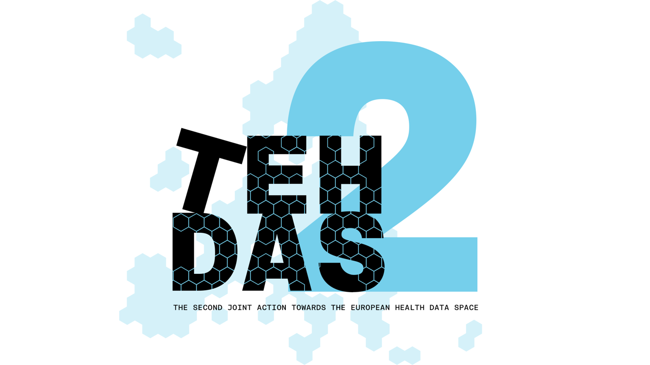

M8.2 Draft Guideline for Health Data Access Bodies on informing natural persons about the use of health data – “Citizen Information Point” – public consultation questions

TEHDAS2 – Second Joint Action Towards the European Health Data Space

21 April 2026

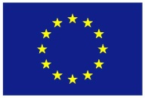
Co-funded by
the European Union

0 Document info

Disclaimer
Views and opinions expressed in this deliverable represent those of the author(s) only and do not necessarily reflect those of the European Union or HaDEA. Neither the European Union nor the granting authority can be held responsible for them.

Copyright Notice
Copyright © 2024 TEHDAS2 Consortium Partners. All rights reserved. For more information on the project, please see www.tehdas.eu.

1 Introduction
By committing to a rigorous public consultation process, the TEHDAS2 project ensures that its deliverables are not only compliant with regulatory requirements but also practical, feasible, and supported by the community they are intended to serve.

1.1 Part A questions for generic feedback
These questions will be asked in each public consultation to provide an understanding of the recipients’ demographics, the quality of the document and to gather generic feedback. Questions marked with an asterisk are mandatory.

Demography
Country* [-List of countries-, EEA (Iceland, Liechtenstein and Norway, Europe non-EEA,European Organisation (European Commission, EMA, etc.), International Organisation (UN, WHO, etc.), Other] Netherlands
Type of the responder* [Public organisation, Private organisation, Non-governmental organisation (NGO), Academic or research institution, Interest group, Individual expert or professional, Patient representative, Individual citizen, Other]: Research infrastructure
Are you responding on behalf of several organisations?* Yes/No
If yes: On behalf of how many organisations?
Sector* [Health care provider, Health care administration, Government/public administration, Research and development, Manufacturer of medical devices, Pharmaceutical industry, Education and academia, Information technology, Data management/processing, Patient advocacy, Legal and compliance, Information & media, Other]: Research infrastructure
Organisation size* [Micro (1–9 employees), Small to medium enterprise (10–249 employees), Large enterprise (250+ employees), Not applicable/Individual citizen
Professional role/function [open text field] Program manager

Quality
Is the document easy to understand?* [Rate 1 (Not clear nor easy to understand) – 4 (Very clear and easy to understand)]
4

How well does the document address the key issues and challenges related to its subject matter?* [Rate 1 (Not well) – 4 (Very well)]
3
How feasible do you find the guidelines or technical specifications presented in the document?* [Rate 1 (Not feasible at all) – 4 (Very feasible)]
4

Generic feedback
Do you have any suggestions for improving the document? Are there any additional topics or areas that should be covered? [Please provide feedback and ideas for enhancing the document] [max. 5000 characters]
The guideline has a strong foundation: the CIP is viewed not only as a compliance tool, but as a public transparency and accountability infrastructure. The focus on accessibility, plain language, user testing, searchability, project results, and a national one-stop shop is also valuable. The guideline often states the right principles, however, it does not always make it sufficiently concrete how HDABs should implement them. In particular, layered information, representative user testing, safeguarding adequate responses to citizens reaching out as a result of communicating contact information, cross-border harmonisation, and honest communication about risks and limitations deserve refinement. More explanation is given in the questions below.
We observe that the connections and alignment between the different guidelines are not sufficiently clear. Greater consistency and cross-referencing between the guidelines would improve coherence, reduce the risk of conflicting interpretations, and facilitate more effective implementation.
We observe that the guidelines have largely been developed and described as separate documents by different authors (which is understandable), but therefore there is limited visibility of how they relate to one another within the broader process. Greater horizontal alignment across the guidelines is needed to support a clear and coherent data journey. This would help stakeholders understand how the different components fit together, ensure consistency across the framework, and facilitate practical implementation throughout the entire data lifecycle.
Another concern we would like to address is that the TEHDAS guidelines timelines do not always match the comitology implementing acts timelines, which make it hard to assess the effect of the input on both trajectories and how input on the guidelines will have effect on the implementing acts. Timeline alignment is needed.

Part B Questions for specific feedback
[All following questions are mandatory]

Generic questions
Are you currently part of a Health Data Access Body (HDAB) and/or do you expect to have a role in fulfilling HDAB responsibilities under the EHDS Regulation in the future? Multiple choices are possible.*
- Yes, I am currently part of an HDAB
- No, but I expect to take part in HDAB roles/responsibilities in the future
- No, but I work closely with HDABs or support their work
- No, I do not expect to be involved in HDAB responsibilities

How familiar are you with national requirement of health information portals?*
- Not at all
- Some knowledge
- Advanced knowledge on some aspects
- Advanced knowledge on all aspects

Will this guideline impact your organisation or activities?*
[Yes / No – please explain]

Yes

Guideline structure and readability
Is the scope and aim of the guideline clearly described?*
[Yes / No – please explain]

Yes

What are your thoughts on the terminology used in the document? Is it clear and appropriate for the context? Please explain your answer.*
The terminology (Citizen Information Point) is clear and appropriate for the context.

Is the overall structure of the guideline (e.g. division into mandatory and optional information) helpful for HDABs setting up a citizen information point?*
[Yes / Somewhat / No – please explain]

Yes

Are the responsibilities of HDABs well distinguished from optional features, good practices and other non-mandatory considerations? If not, please explain your answer.*
[Yes / No – please explain]
Yes

Do you see any challenges in setting up the citizen information point when following the guideline?*
[Yes / No – please explain]

Yes, we anticipate some challenges. The guideline emphasizes that the Citizen Information Point (CIP) should be well-structured, easy to understand, and tested with end users, which we fully support. However, we see a potential tension between providing all mandatory information and maintaining clarity and accessibility. In particular, presenting comprehensive information without overwhelming users may be difficult. While the guideline highlights the potential of a CIP to enhance citizens’ awareness, trust, and engagement, there is also a risk of the opposite effect. For example, if visitors encounter a large number of data access requests or complex information they did not expect, this could lead to confusion or even mistrust rather than increased confidence.

Additionally, several paragraphs indicate that contact information should be provided (e.g. on page 13: contact details of the data user and the HDAB). This enables citizens to contact the HDAB or data user. It is important to ensure that citizens receive a timely and accurate response. While HDABs may be well-prepared to handle such inquiries, this may be more challenging for data users, for whom responding to questions from citizens could be new, complex, or unexpected. This raises the question of how to ensure that data users are adequately equipped to respond in a timely and correct manner. If citizens’ questions are not answered (or not answered correctly), this could undermine trust in the secondary use of data. Providing guidance on this issue would be beneficial—for example, by creating awareness amongst data users that their contact details will be made publicly and that they might receive questions, by clarifying responsibilities, offering support mechanisms, or setting minimum expectations regarding follow-up on citizens questions.

Guideline content, implementation feasibility
To what extent does the guideline provide a helpful and feasible interpretation of Article 58 of the EHDS Regulation?*
Please rate on a scale of 1 to 4, where 1 means “not at all” and 4 means “to a large extent”.

3

Do the implementation considerations in the document reflect the purpose of CIPs to provide easily accessible information about secondary use of health data to citizens?*
(Yes/No > What changes or additions would help?)

Yes

Does the guideline sufficiently account for accessibility for a diverse audience?*
(Yes/No > What changes or additions would help?)

No. The guideline does mention a user-centred design approach, validated through testing with real users, and provide guided pathways to support citizens with limited digital skills. This is positive. It could be highlighted that the CIP should be tested with a representative group (reflective of society, including people with low literacy, low health literacy, language variation and disabilities) to prevent the CIP is only tested with, for example, higher educated citizens with backgroud knowlegde of health and research. Furthermore, the CIP should not only provide human-readable pages but also machine-readable formats, such as JSON, CSV export or an API, to support a diverse audience (including patient organisations and watchdogs) in enabling oversight, facilitate research and cross-border aggregation. Additionally, HDABs should keep internal audit logs showing who changed CIP content, when, based on which source decision. Lastly, every data access request, permit, dataset, data user, data holder and result should have stable public identifiers and persistent URLs, so entries can be cited, monitored and revisited over time.

Are there any legal, ethical or procedural issues that remain unclear or unresolved in the current version of the guideline?*
- Unclear legal issues (Yes > Please explain: / No) No.
- Unclear ethical issues (Yes > Please explain: / No) Yes. From consultations with the public (including patients) it became clear that information should not only cover the benefits and positive results of data use, but should also cover the risks, topics that might be considered sensitive (e.g., commercial companies as data user) and the limitations on the right to opt-out. Showing the complete picture and indicating how risks are mitigated fosters trust. Furthermore, the guideline mentions the use of AI to translate information. Could the guideline provide more guidance about the use of AI for other purposes than translation, i.e. to collect, summarize or distribute information? Lastly, the guideline should include information on misuse or security issues of the CIP: threat modelling for scraping, inference attacks, linkage risks, accidental publication of protected information, trade secret redaction and misuse of published contact details.
- Unclear procedural issues (Yes > Please explain: / No) Yes. Clarification would also be appreciated on how to approach international data use. In particular, should the information provided be harmonised across Member States (i.e. consistent and identical information about the data use in all countries), or is it acceptable for Member States to apply different approaches and formats when providing information in response to the same request? Greater guidance on this point would support consistency and legal certainty in cross-border contexts. Additionally, the guideline mentions that significant findings are covered in other guidelines. However, how to feedback significant findings to citizens was not covered in the guideline for HDAB’s on implementing the obligation of notifying the natural person on a significant finding (which was consulted in the previous wave), nor does it seemed to be explained in the guideline for data users on handling research outcomes (which is currently under consultation). More guidance on communicating significant findings to citizens would be helpful.

What kind of support would be most helpful for an HDAB to set up a citizen information point according to this guideline?*
Please select all that apply.
- Templates (e.g. for dashboards or text passages)
- A helpdesk or advisory mechanism (EU level) or exchange across HDABs
- More examples in the guideline
- Training or workshops
- Other: (please specify) Annex 5 describes several existing portals. These portals could form an example of how a portal could be structured. Currently, if we read it correctly, we can not see exactly which portals are described, except for the portal in footnote 13. Would it be possible to provide links to more portals? We think it would help to have several examples.

What is an information point
How well does the guideline support your understanding of citizen information points?* Please rate on a scale of 1 to 4, where 1 means “not at all” and 4 means “to a large extent”.
- Clarity of definition: scale 1–4, 4
- Relevance of examples: scale 1–4 3
- Usefulness of implementation guidance: scale 1–4 3
- Optional comment or examples: More extensive examples would be helpful

What information should be provided?
How well does the guideline support your understanding of what information should be provided?*
Please rate on a scale of 1 to 4, where 1 means “not at all” and 4 means “to a large extent”.
- Clarity of definition: scale 1–4, 4
- Relevance of examples: scale 1–4, 4
- Usefulness of implementation guidance: scale 1–4, 3
- Optional comment or examples: Example paragraphs about common topics (e.g. the legal bases, common safeguards, et cetera) would be very helpful. Regarding the lay summaries of research results, a workflow could be defined, including reminders to data users, validation by the HDAB (on completeness, plain-language quality, consistency with the permit, absence of misleading claims and absence of re-identification risk), publication, persistent links and archival. Additionally, on page 13, it is mentioned that inclusiveness requires non-electronic possibilities, more information on what this could look like would be useful. Lastly, the guideline mentions the relation to information about secondary use outside the EHDS scope, which is important. We want to stress that if only EHDS applications are visible, but other forms of secondary use remain out of scope in the CIP, a false sense of transparency arises.

How should the information be provided?
How well does the guideline support your understanding of how information should be provided?*
Please rate on a scale of 1 to 4, where 1 means “not at all” and 4 means “to a large extent”.
- Clarity of section: scale 1–4, 2
- Relevance of examples: scale 1–4, 4
- Usefulness of implementation guidance: scale 1–4, 3
- Optional comment or examples: Examples of potential dashboard layouts and links to existing portals would be very helpful. Furthermore, the guideline mentions that the information is understandable by readers with different knowledge and capacity, which we fully support. Although ‘layers’ are mentioned on page 20, it would be good to explicitly add that a layered information structure might be beneficial, with an easy to understand top layer, but more detailed or complex information (with hyperlinks to the EHDS legislation itself) in a deeper layer, to ensure that there is sufficient information for citizens who want to read the details. The guideline mentions two interfaces, one for citizens and one for professionals. However, separate interfaces can create inconsistent information; duplicated maintenance; uncertainty about which interface someone should use; a risk that citizens are only shown simplified information; and a false assumption that professionals always need detail and citizens never do. The Patient and Public Advisory Committee recommends one coherent Citizen Information Point, built on a unified backend and shared source information, with layered content, filter and search functionalities, summaries, expandable detail and downloadable documents. Search and filter functionalities should support what citizens and oversight actors need, such as disease area, data user type, country, dataset category, purpose, commercial or non-commercial actor, project status, publication date and whether results are available.
- Page 18 says ‘As discussed in chapter 3, the information required under Article 58 could be presented alongside the information and documents published under Article 57(1).’ Some examples are given (‘links for each data access application and corresponding data permit’). The sentence refers to chapter 3, but in chapter 3, we only read ‘The CIP forms part of the elements to be published by the HDAB under Article 57(1)(j)(vi) of the EHDS regulation (see chapter 4).’ Article 57(1)(j)(vi) relates back to article 58. Therefore, we suggest leaving out the reference to chapter 3 from the sentence on page 18.
- On page 18, in the paragraph on structure, there is some information that does not relate to structure (e.g. the information where the CIP should be transparent about). We suggest moving this content to the paragraph on what information should be given, in order to make sure that the paragraph about structure is truly about structure and not about the content.
- Minor detail: on page 20, in the first sentence, the word ‘of’ is misspelled as ‘og’.

When should the information be provided?
How well does the guideline support your understanding of when information should be provided?*
Please rate on a scale of 1 to 4, where 1 means “not at all” and 4 means “to a large extent”.
- Clarity of timeline: scale 1–4, 4
- Relevance of examples: scale 1–4, 3
- Usefulness of implementation guidance: scale 1–4, 3
- Optional comment or examples: It would be helpful if the guideline could further clarify what is meant by “without undue delay.” We recognise that this concept may vary across Member States; however, providing at least an indicative timeframe or general boundaries—particularly outlining situations that would clearly not qualify as “without undue delay”—would greatly enhance consistency and practical applicability.
- Minor detail: on page 22, the EHDS is misspelled as ‘EEDS'.

